# [C:\Users\jwoo5\AppData\Local\Temp\templateTermTutorial.html](http://www.calstatela.edu/centers/hipic) CIS4580 Term Project Tutorial https://avatars2.githubusercontent.com/u/4156894?v=3&s=100

California State University, Los Angeles

#### Authors: Andrew Rosalino; Andrew Tran; Edgar Manukian; Thomas Lew; Brian Sangalang

#### Instructor: [Jongwook Woo](https://www.linkedin.com/in/jongwook-woo-7081a85)

**Used Car Data Analysis from CarGurus using Hive, Pig, and PowerBI**

**Objectives**

* Upload data and Analyze via wget
* Create a table and test data via Hive
* Clean and test data via Pig
* Store and Export data into Hadoop then Local Machine
* Visualizations and Analysis using PowerBI

**Platform Specifications**

* Cluster Version: 2.7.1
* Cluster Number of Nodes: 3
* Memory Size: 180 GB
* OCPUs: 12

Step 1: Upload and Analyze Used Car Data in Hive

**1.** Open a shell terminal – git bash, minty, putty etc- and run the ssh command to connect to the Oracle Cloud.

ssh **atran80**@129.150.64.74

**2.** In your shell terminal, you have to download the following file “archive.zip”.

$ wget <https://cis4560.s3.us-east-2.amazonaws.com/archive.zip>

**Alternatively, the dataset is also hosted on Kaggle:** <https://www.kaggle.com/ananaymital/us-used-cars-dataset> **(2GB Compressed, 8GB Uncompressed)**

**3.** Unzip “archive.zip”

$ unzip archive.zip

**Archive: archive.zip**

**inflating: used_cars_data.csv**

**4.** Create car folder of your HDFS:

$ hdfs dfs -mkdir car

**5.** Upload used_cars_data.csv file to car folder of HDFS:

$ hdfs dfs -put used_cars_data.csv car/

$ hdfs dfs -ls car/

**Found 1 Items**

**-rw-r--r-- 2 atran80 hdfs 9980208148 2020-11-27 23:47 car/used_cars_data.csv**

**6**. Run the following HDFS command to make your *beeline* command works.

hdfs dfs -chmod -R o+w car/

Make sure if it has a permission for others:

-bash-4.1$ hdfs dfs -ls car/used_cars_data.csv

**-rw-r--rw- 2 atran80 hdfs 9980208148 2020-11-27 23:47 car/used_cars_data.csv**

**7**. Open an another terminal to run **beeline** and run “**!connect….”**.

beeline

!connect jdbc:hive2://bigdai-nov-bdcsce-1:2181,bigdai-nov-bdcsce-2:2181,bigdai-nov-bdcsce-3:2181/;serviceDiscoveryMode=zooKeeper;zooKeeperNamespace=hiveserver2?tez.queue.name=interactive bdcsce_admin

**8**. **Call** your database of Hive as follows:

0: jdbc:hive2://bigdai-nov-bdcsce-1:2181,bigd> use **atran80**;

**9**. Then, you need to create **cardata** table using the following Hive command – Alternatively, you can open Hive environment at the shell terminal to run it. See the option “'skip.header.line.count' = '2'”, which is to skip the header line of CSV file that you don’t need.

|  |
| --- |
| DROP TABLE IF EXISTS cardata;  --create table cardata on space-delimited website log data  CREATE EXTERNAL TABLE IF NOT EXISTS cardata(vin string, back_legroom string, bed string, bed_height string, bed_length string,  body_type string, cabin string, city string, city_fuel_economy int, combine_fuel_economy string, daysonmarket int, dealer_zip int,  description string, engine_cylinders string, engine_displacement int, engine_type string, exterior_color string, fleet string,  frame_damaged string, franchise_dealer string, franchise_make string, front_legroom string, fuel_tank_volume string, fuel_type string,  has_accidents string, height string, highway_fuel_economy int, horsepower int, interior_color string, isCab string, is_certified string,  is_cpo string, is_new string, is_oemcpo string, latitude int, length string, listed_date date, listing_color string, listing_id string,  longitude int, main_picture_url string, major_options string, make_name string, maximum_seating string, mileage int, model_name string,  owner_count int, power string, price int, salvage string, savings_amount int, seller_rating int, sp_id string, sp_name string,  theft_title string, torque string, transmission string, transmission_display string, trimId string, trim_name string,  vehicle_damage_category string, wheel_system string, wheel_system_display string, wheelbase string, width string, year int )  ROW FORMAT DELIMITED FIELDS TERMINATED BY ' '  STORED AS TEXTFILE LOCATION '/user/atran80/car/'  TBLPROPERTIES ('skip.header.line.count'='2'); |

**10.** Use describe to see if table creation was successful:

Describe cardata;

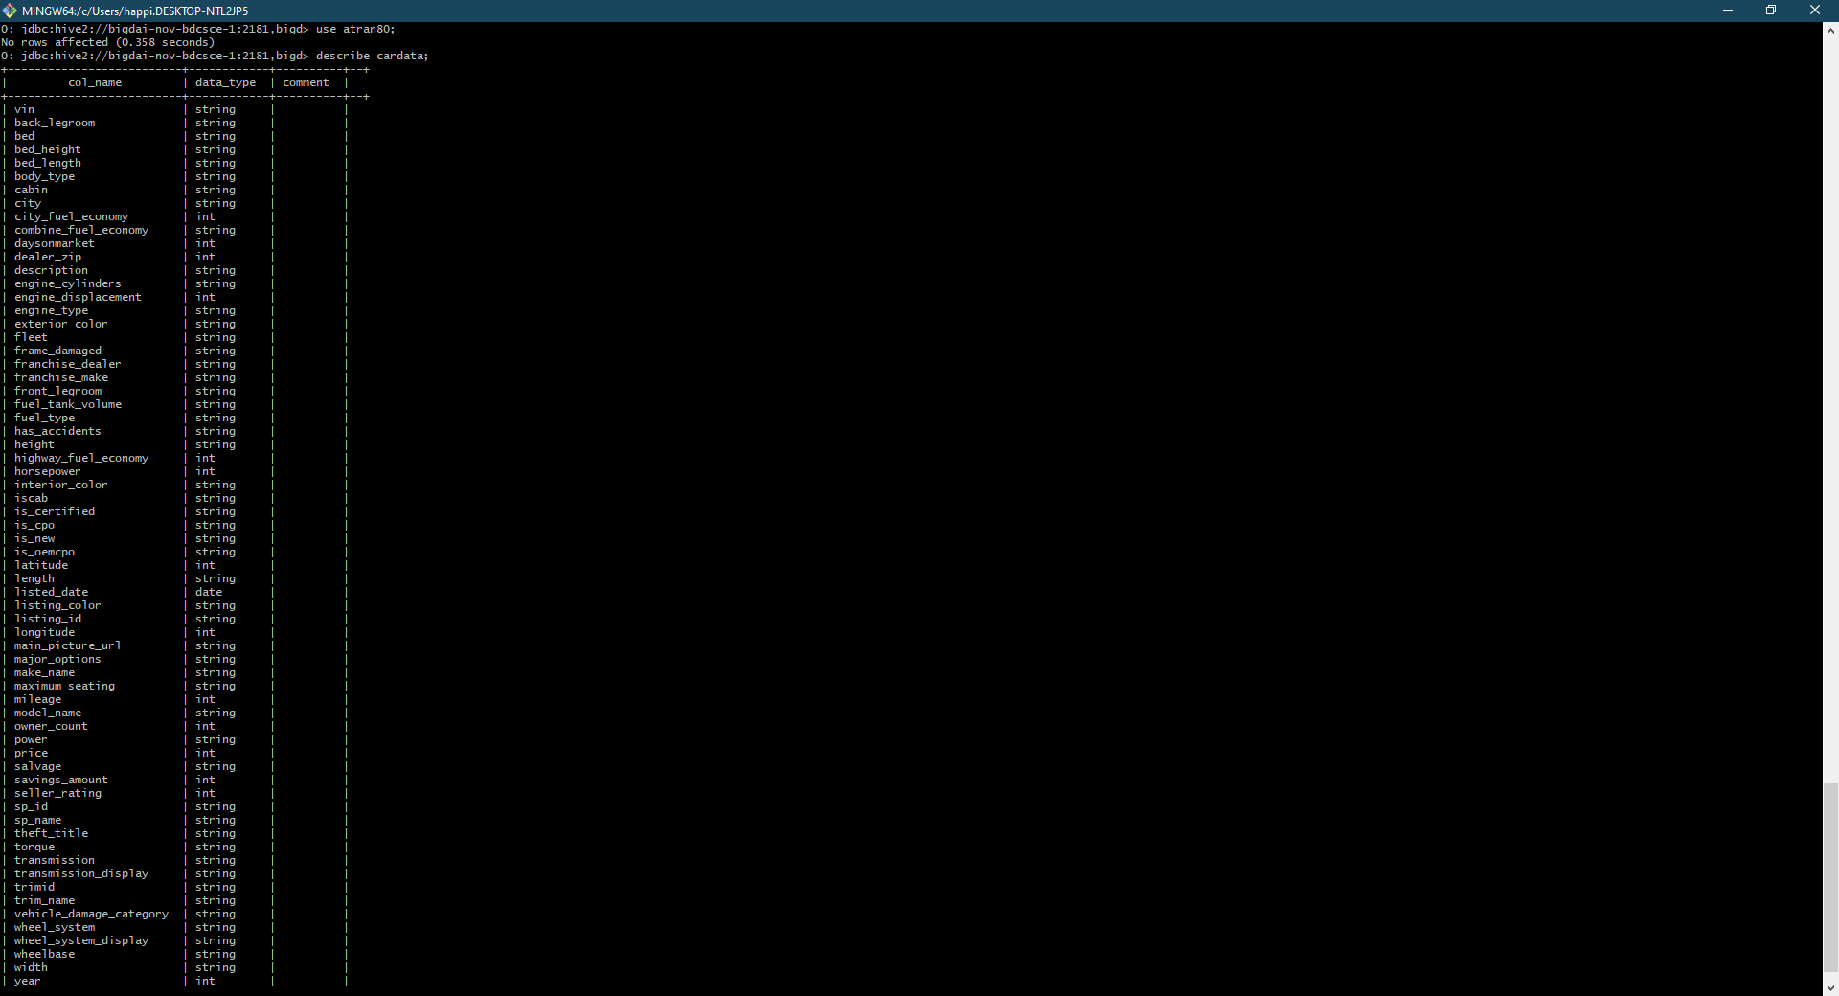

**11.** Run SQL queries to test the dataset:

Select * from caradata limit 10;

Select make_name, model_name, price from cardata order by price desc limit 10;

Step 2: Use Pig to Store and Clean the data

**1.** Enter “pig” into the git terminal and load our data and define the columns (The code is too long to be included here but can be copy and pasted from our Github account):

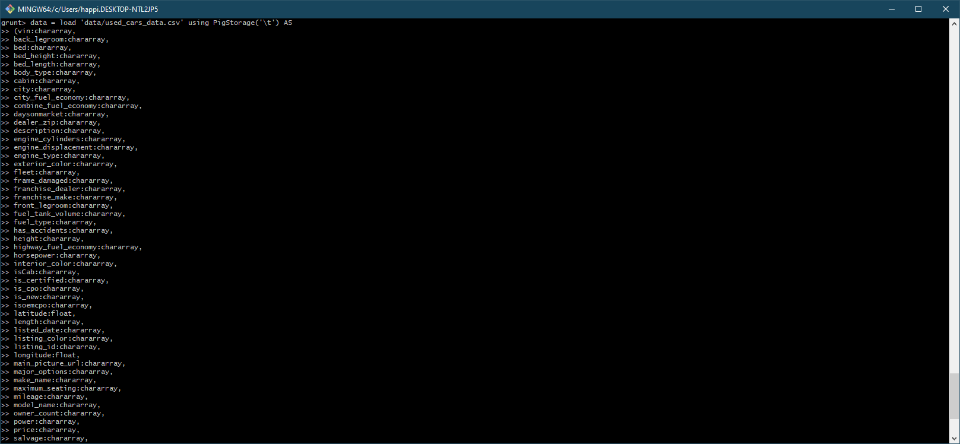

**2.** Describe the data to see if it was successful.

Describe cardata;

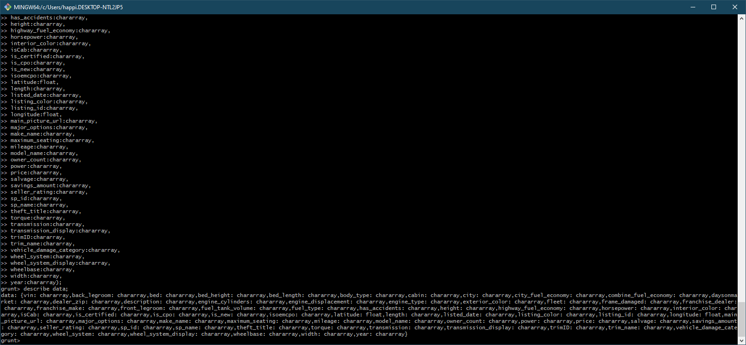

**3.** Filter the data so that only relevant columns are shown.

Filtered = foreach data generate (vin, make_name, model_name, price, city, city_fuel_economy, highway_fuel_economy, combine_fuel_economy, listed_date, daysonmarket, dealer_zip, has_accidents, is_new);

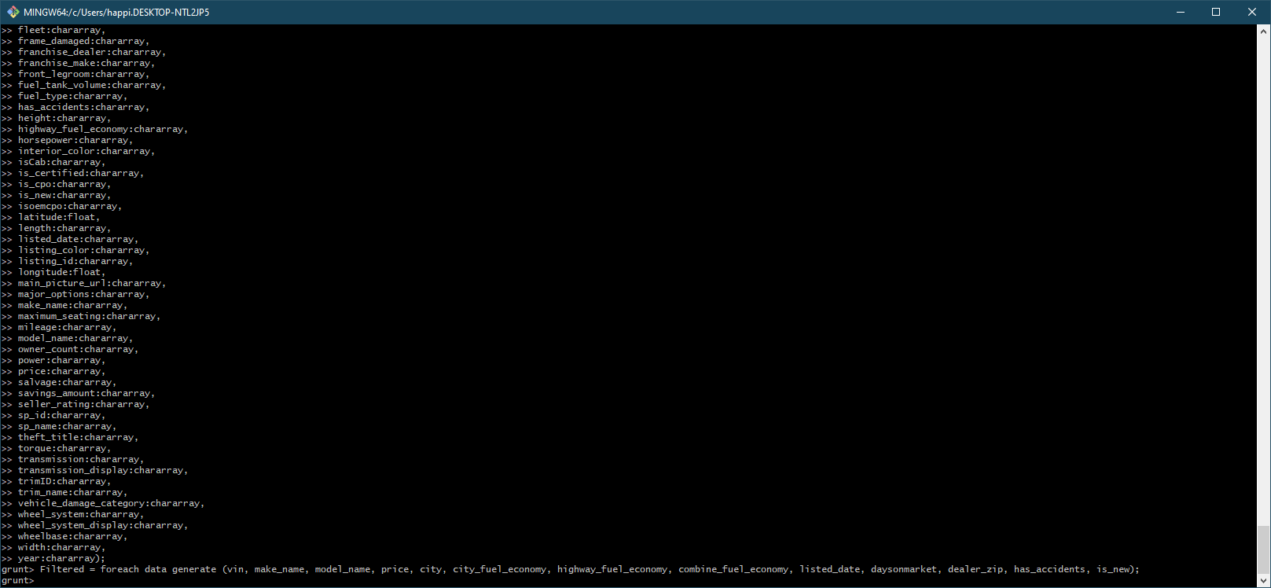

**4.** Test the data using a DUMP command with a limit on it

testfilter = limit Filtered 5;

DUMP testfilter;

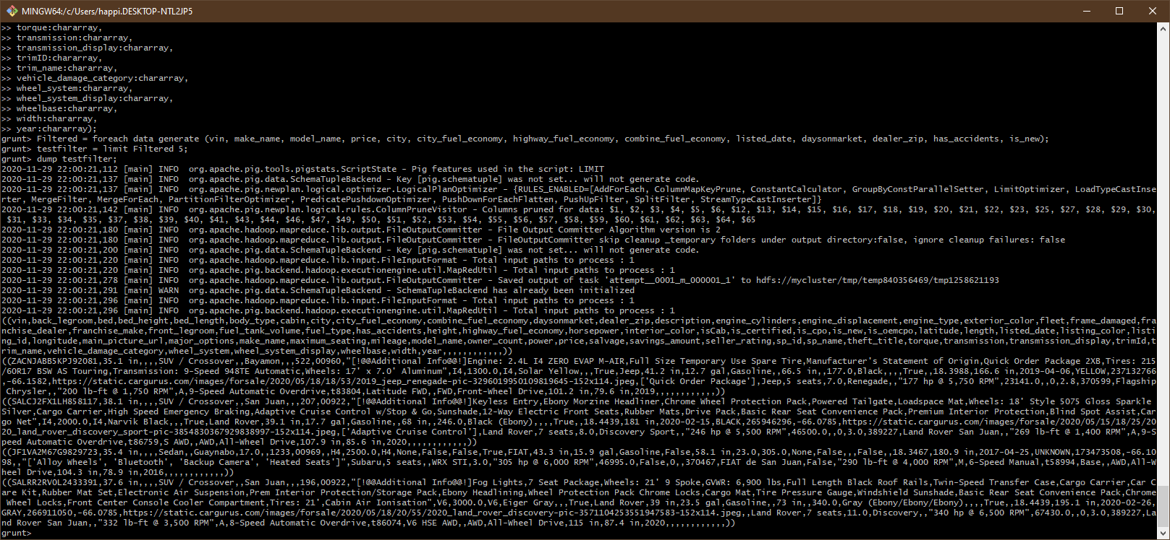

The data does not look very pretty but we can still store it and use PowerBI to analyze it.

**5.** Store Filtered into ‘filtered_car_data.csv’ using PigStorage(‘,’);

store Filtered into ‘filtered_car_data’ using PigStorage(‘,’);

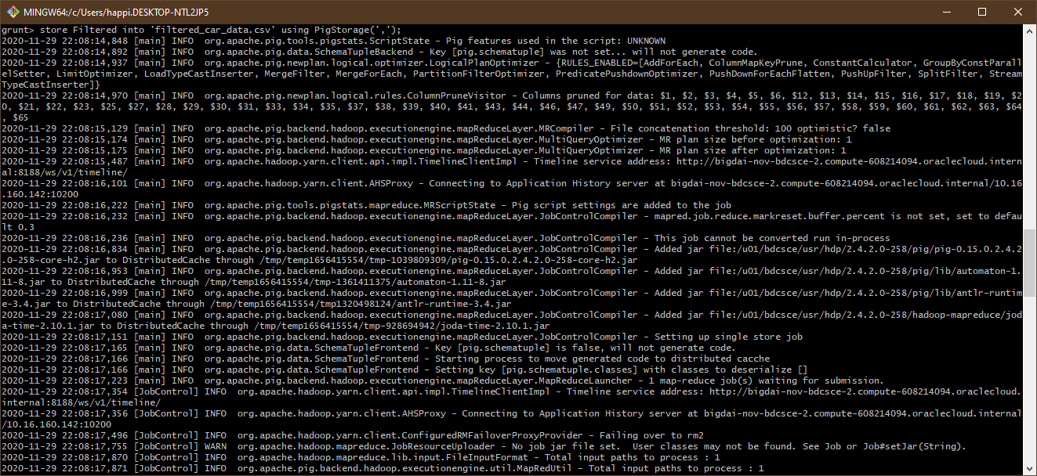

**6.** Check if the file is present and has data in it in Hadoop.

hdfs dfs -ls

hdfs dfs -ls filtered_car_data.csv

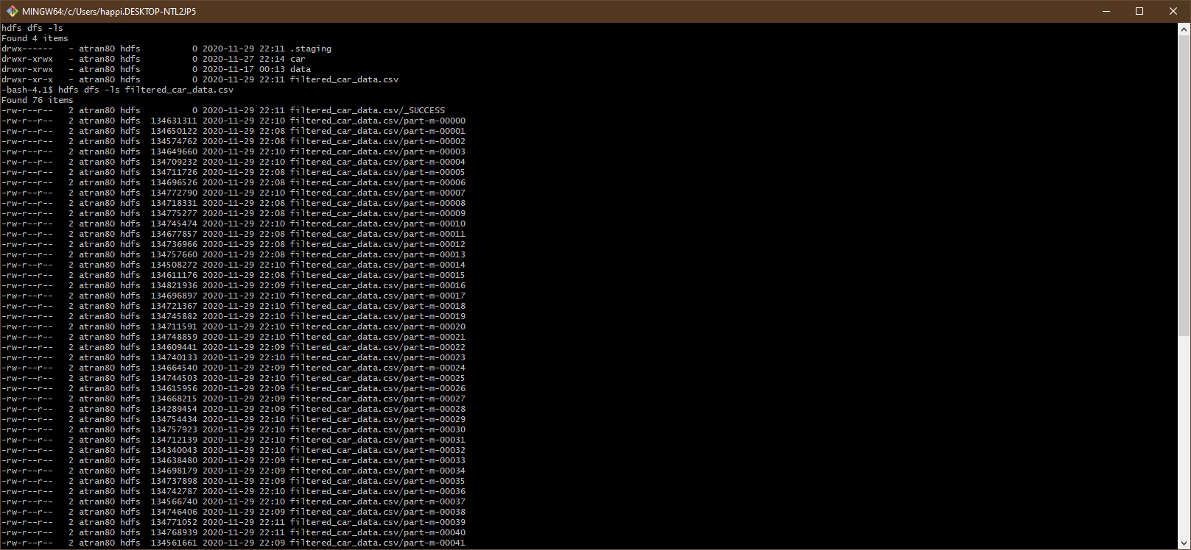

**7.** Convert the Pig results into a CSV.

hdfs dfs -cat ./filtered_car_data.csv/part* > filtered_used_cars.csv

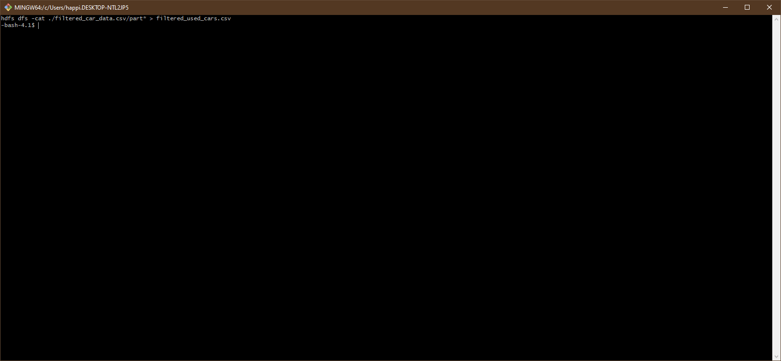

**8.** Download the newly created and filtered csv using SCP

scp atran80@129.150.64.74:./filtered_used_cars.csv used_car_data.csv



Step 3: Visualization using PowerBI

**1.** Sign into PowerBI and upload your new dataset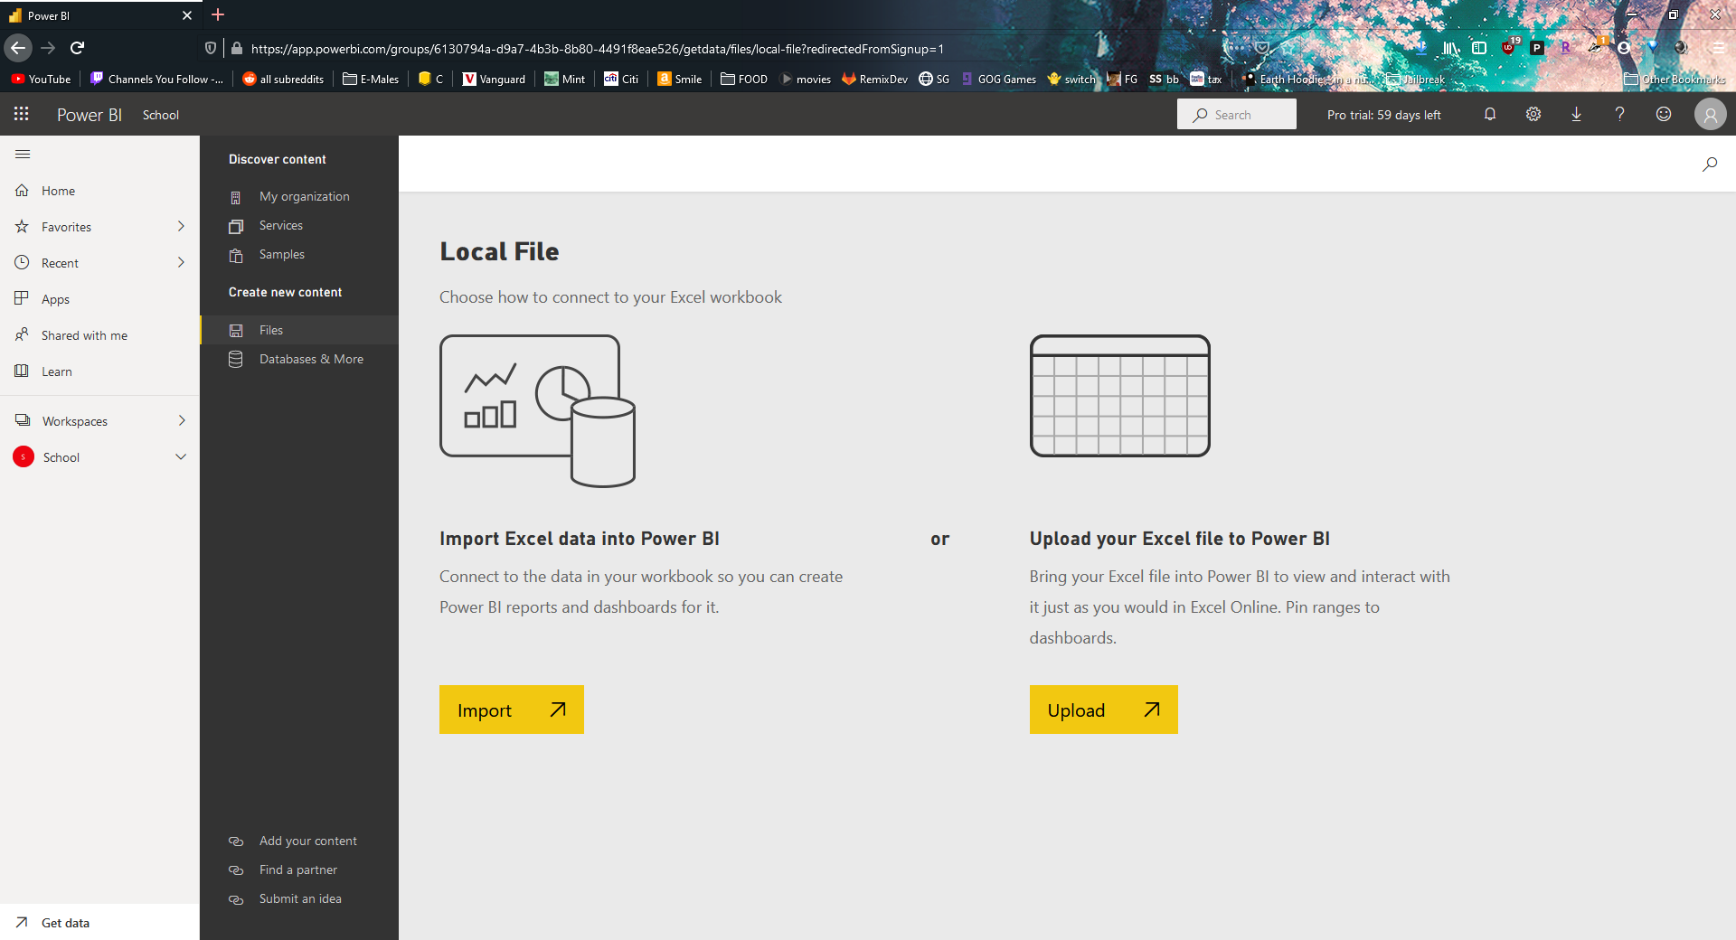

**2.** Create visualizations

Pie Chart showing amount of listed vehicles by year

Select Pie chart icon -> Drag Listed year to legend and vin to values -> change vin to count of vin

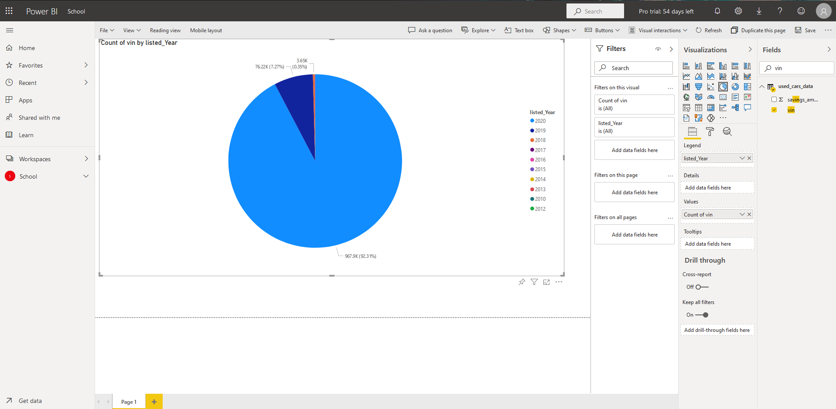

Map detailing number of listed cars in each United States city.

Select Map icon -> Drag city to location -> drag vin to size -> change vin to count of vin

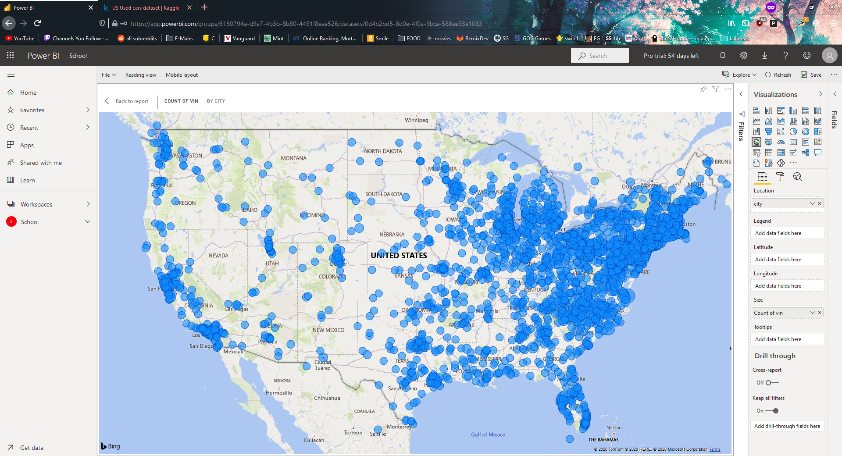

Most popular used car make names.

Drag make name and vin onto the canvas -> change vin to count of vin

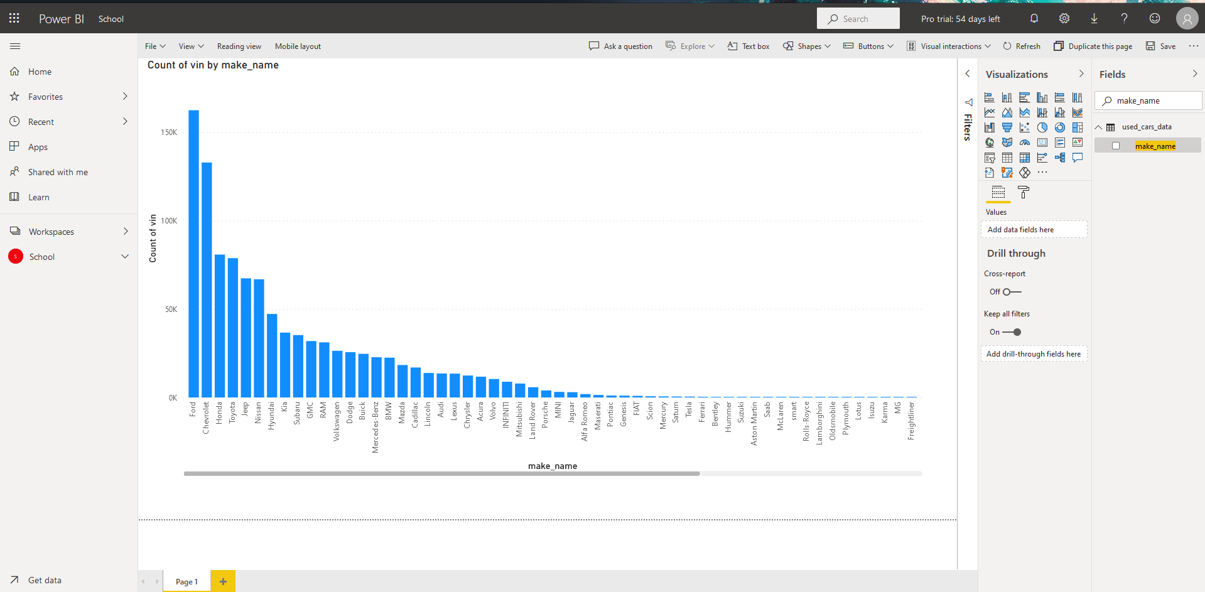

References

* 1. CarGurus used cars dataset: <https://www.kaggle.com/ananaymital/us-used-cars-dataset>
  2. Github: <https://github.com/aylmaokai/CIS4560>
  3. AWS Link: <https://cis4560.s3.us-east-2.amazonaws.com/archive.zip>